**ANKIT TAPARIA STUDENT-ID: 19302722**

**COVID-19 Data Visualization**

***Note:*** *All visualizations shown below are based on the data from 22-01-2020 until 26-03-2020*

**Increasing trend of daily cases**

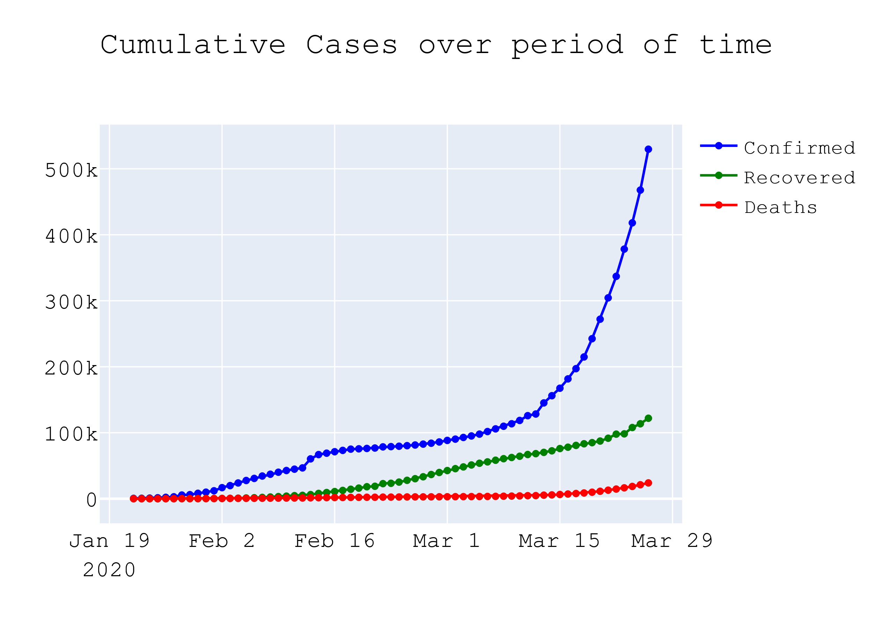

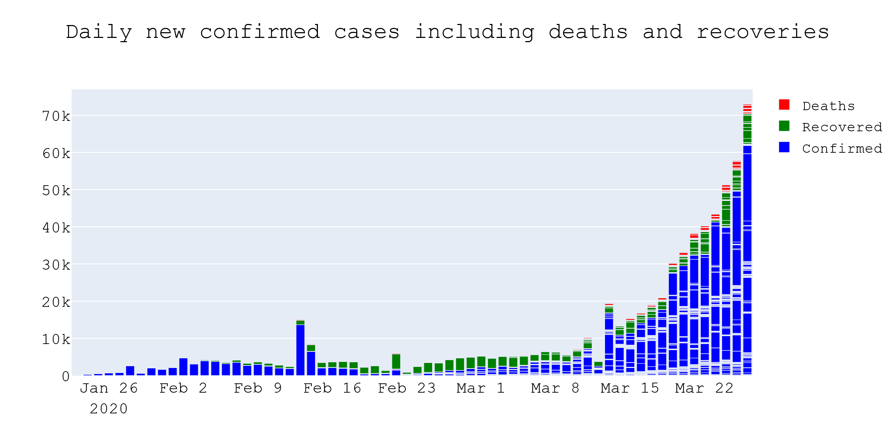

**Total Confirmed cases, deaths, recovered cases and mortality rate**

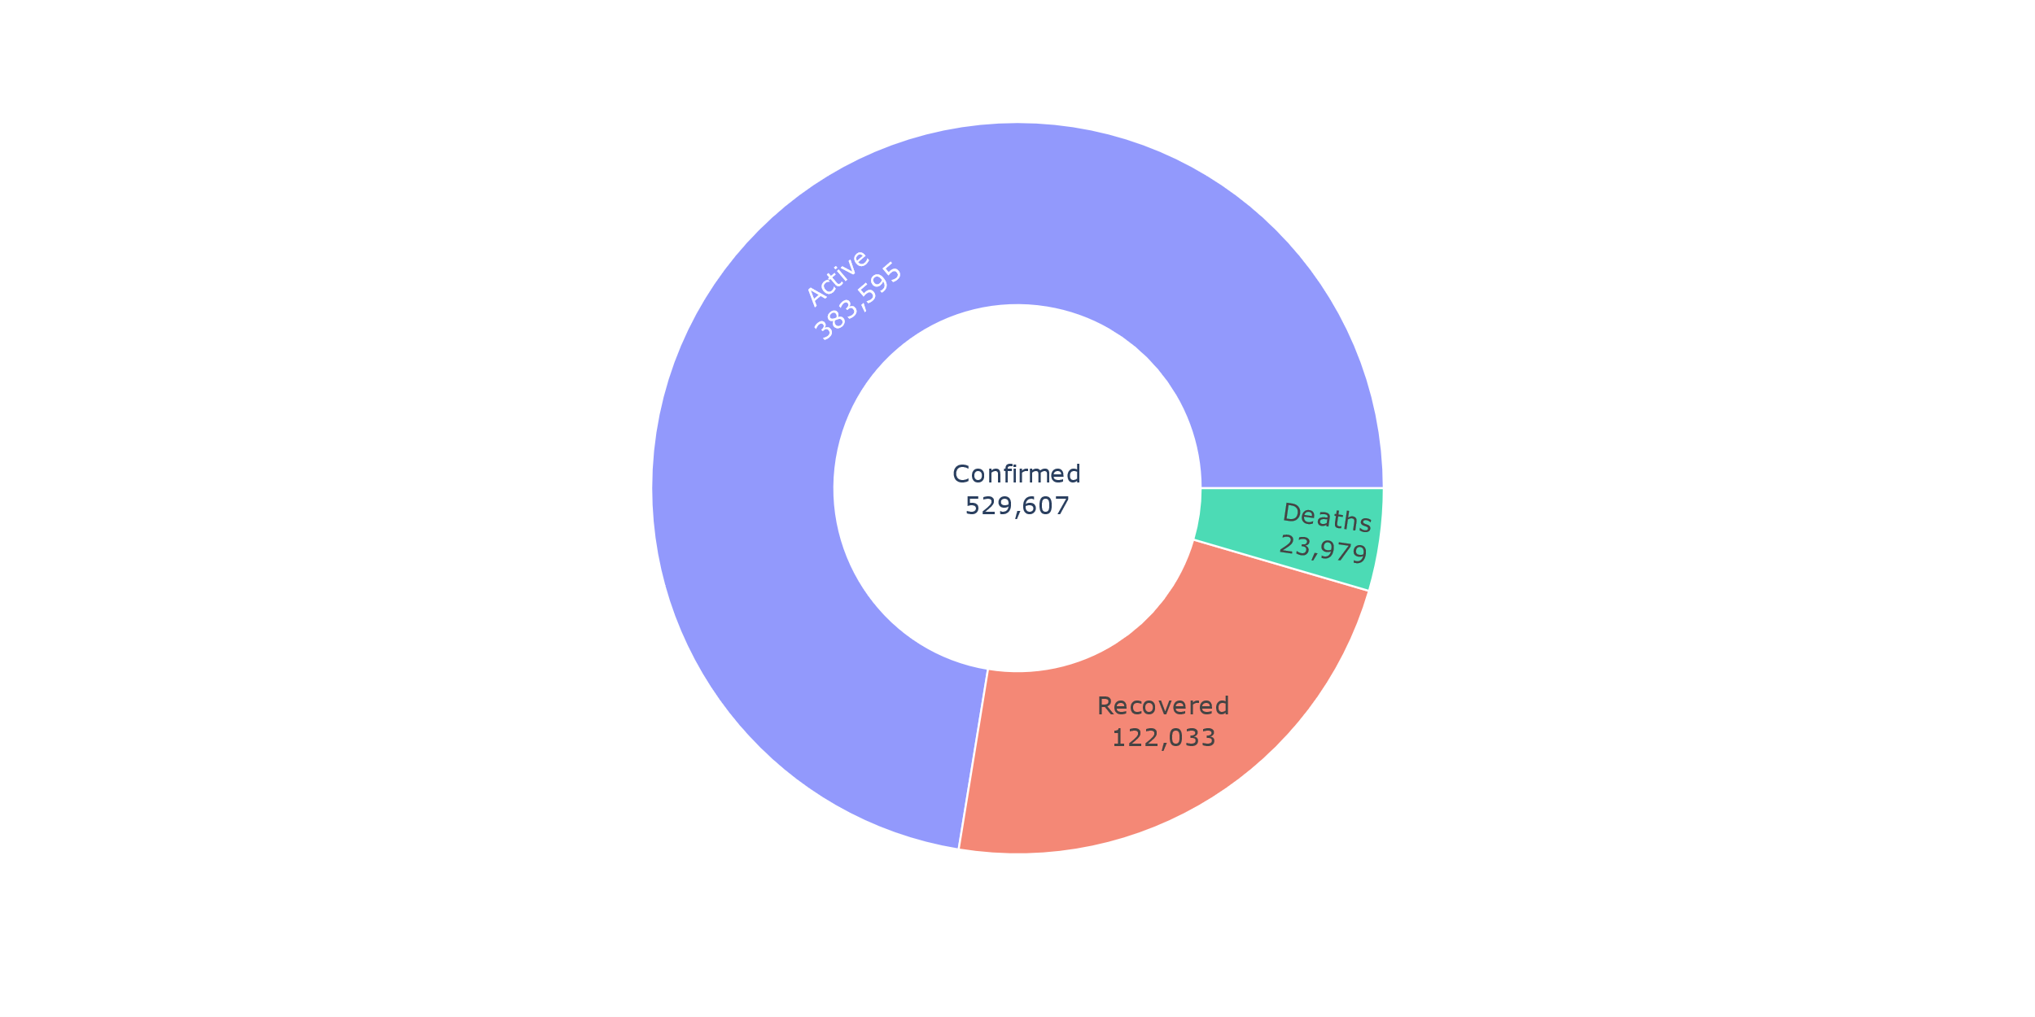

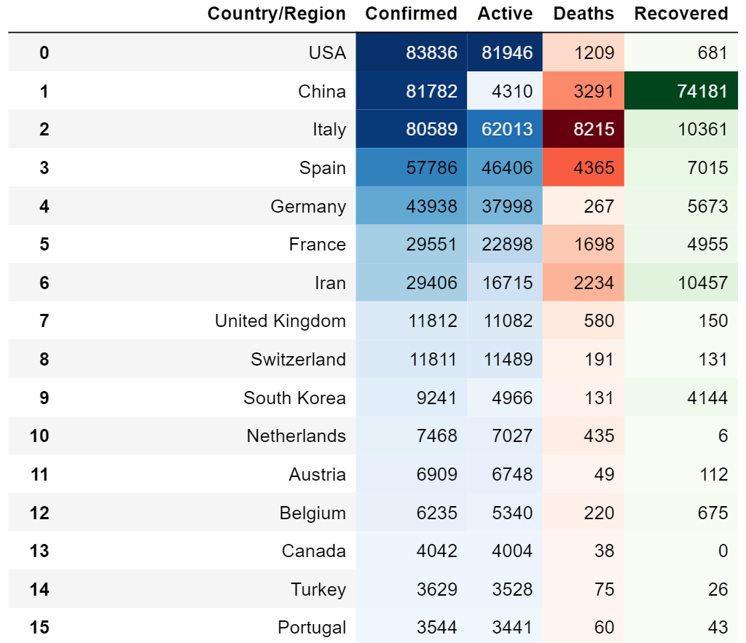

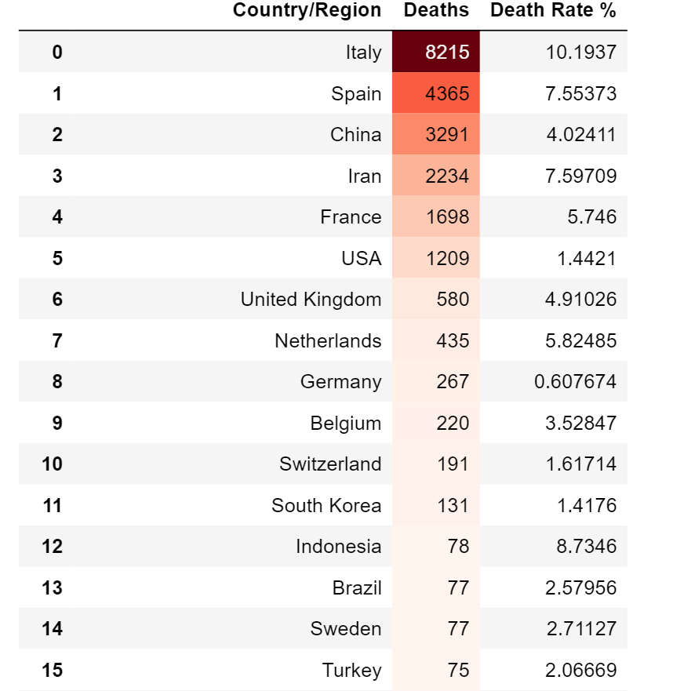

**Composition of COVID-19 cases**

**Trajectories of most affected countries**

Below visualisations shows the trajectories of confirmed cases in top 10 affected countries. The curve flattened for China due to lockdown imposed. The plots also reveal trajectories for Italy and US are steeper than of China.

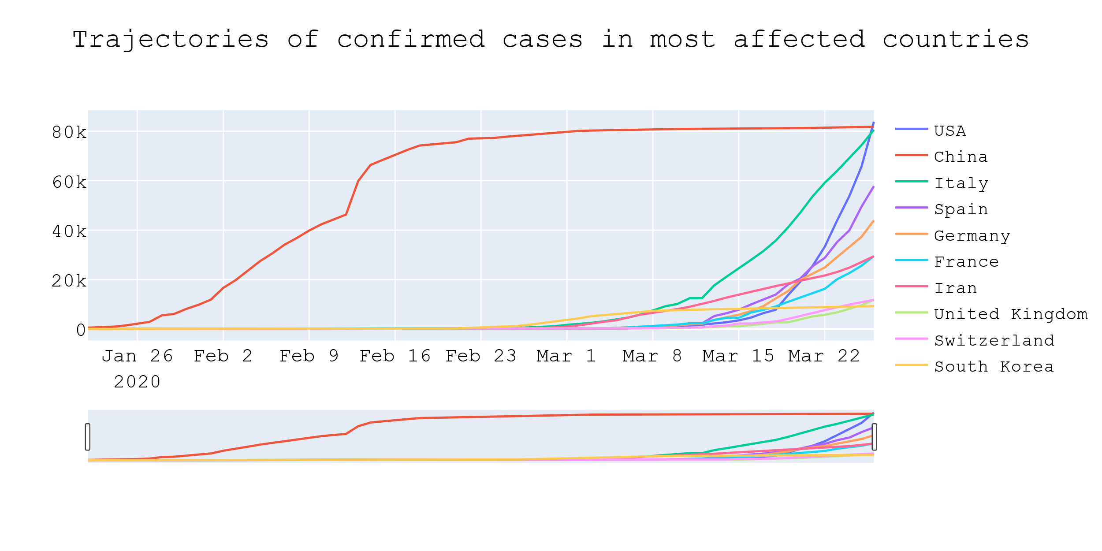

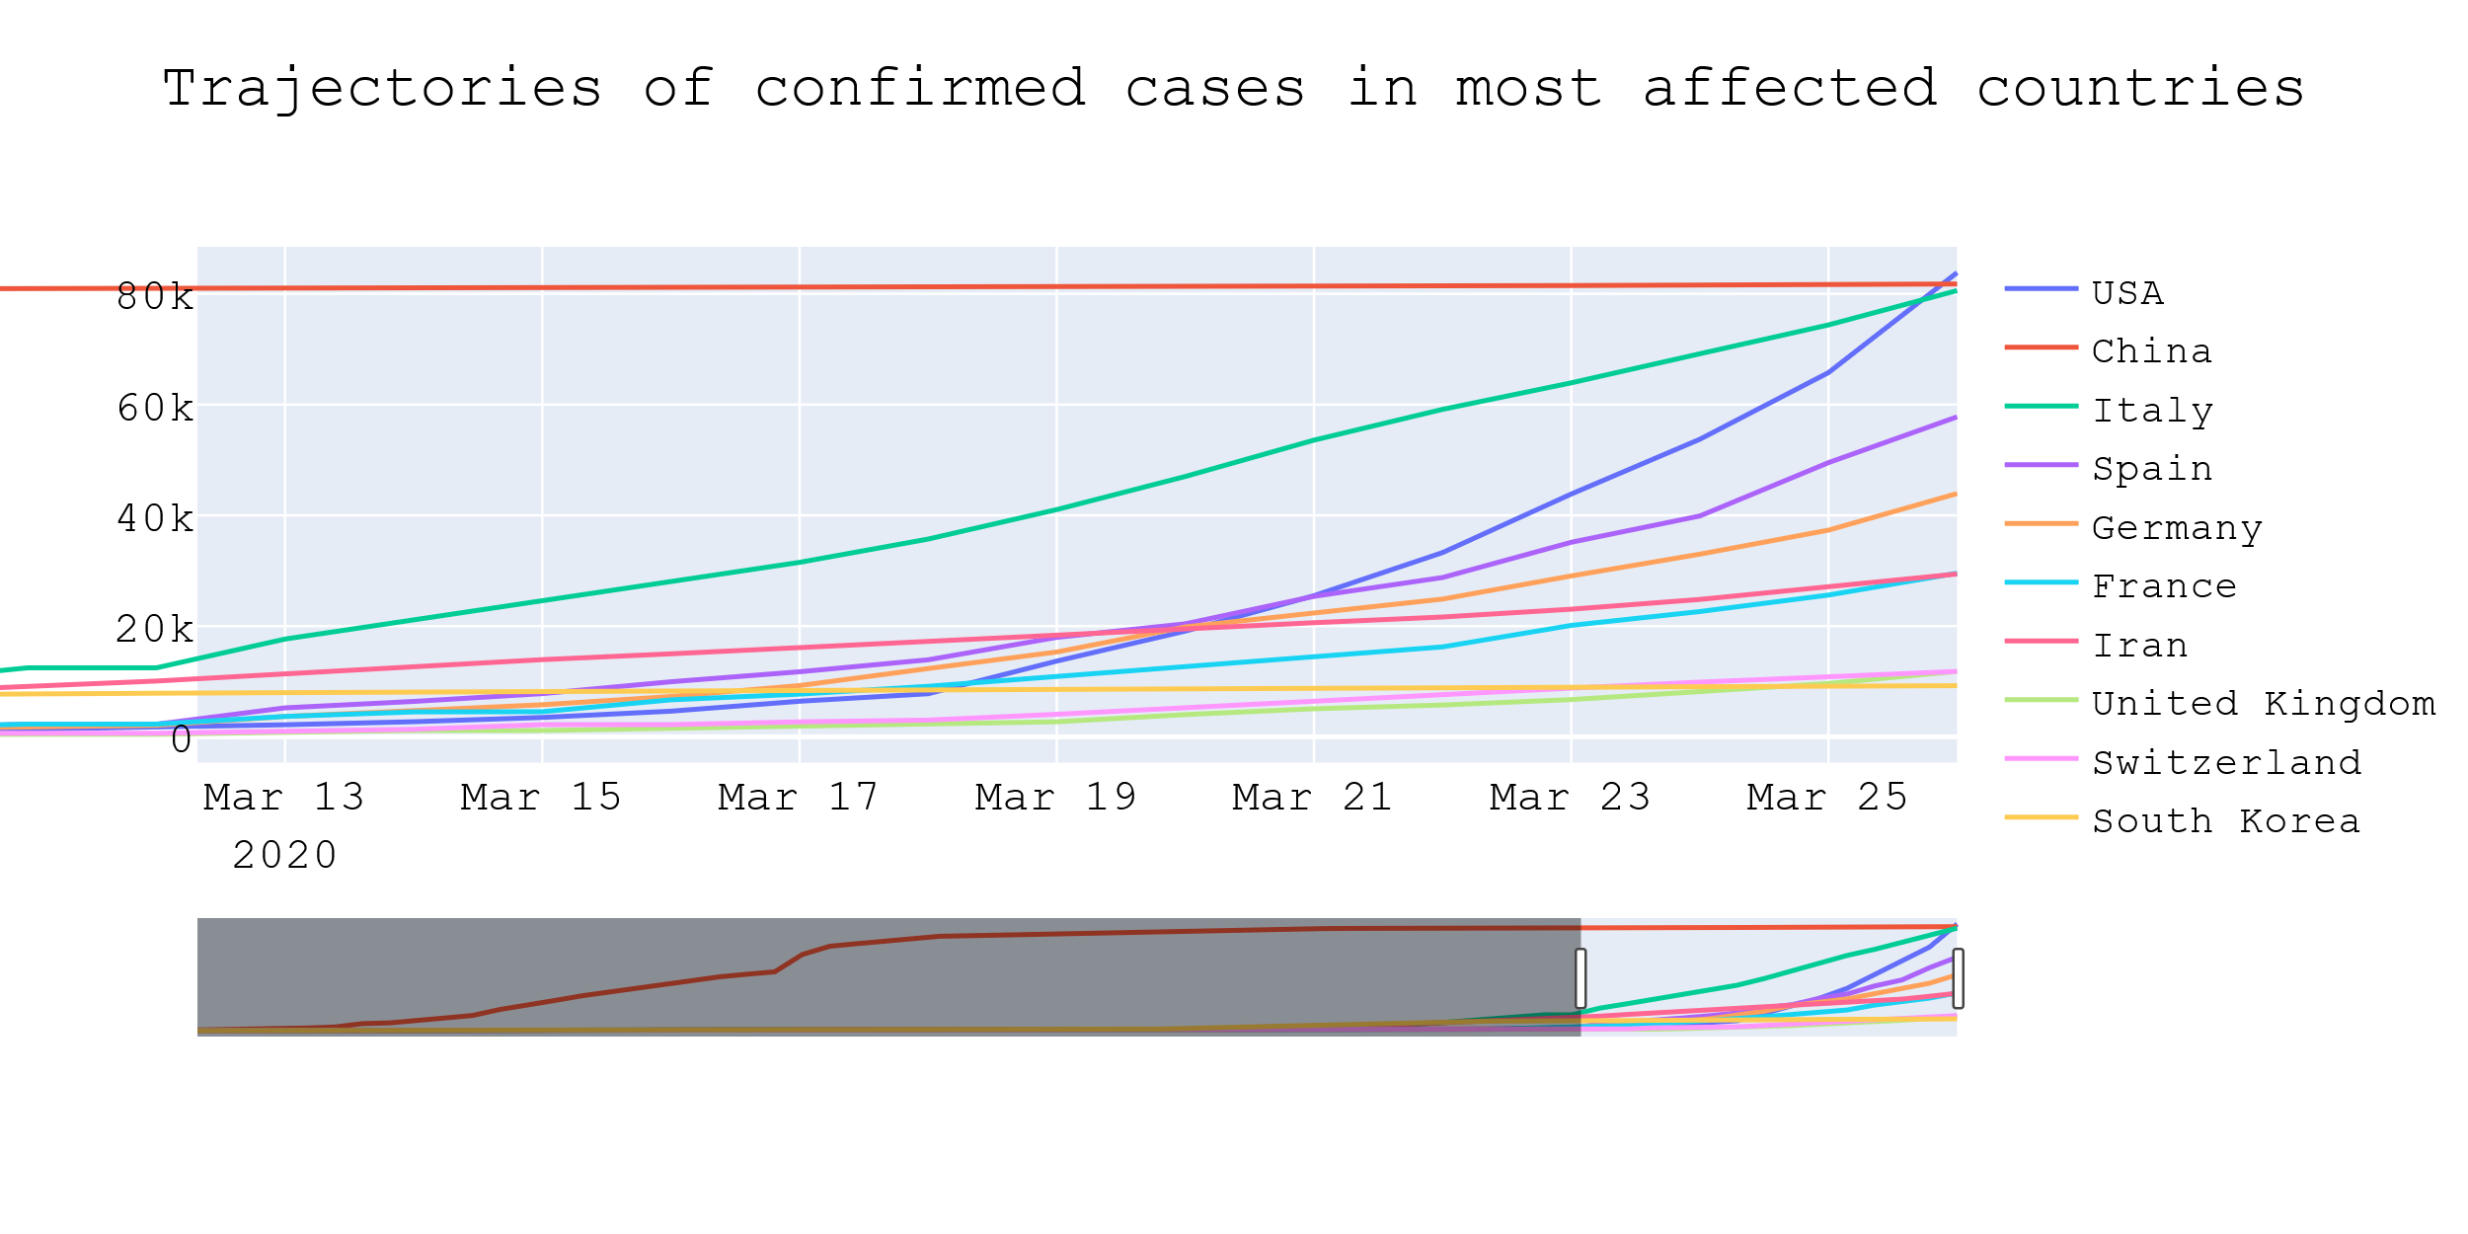

**Spread of cases across continents and shift of epicentre of COVID-19**

